ASSIGNMENT 1.3
NAME : BERELLI PRIYANKA
HALL TICKET NO : 2303A52468
BATCH NO : 42
Task 1: AI-Generated Logic Without Modularization (Fibonacci Sequence Without Functions)
Prompt : Write a Python program that prints the Fibonacci sequence up to n terms.
CODE :
Write a Python program that prints the Fibonacci sequence up to n terms.
def fibonacci(n):
sequence = []
a, b = 0, 1
for _ in range(n):
sequence.append(a)
a, b = b, a + b
return sequence
n = int(input("Enter the number of terms: "))
print(f"Fibonacci sequence up to {n} terms: {fibonacci(n)}")

OUTPUT :
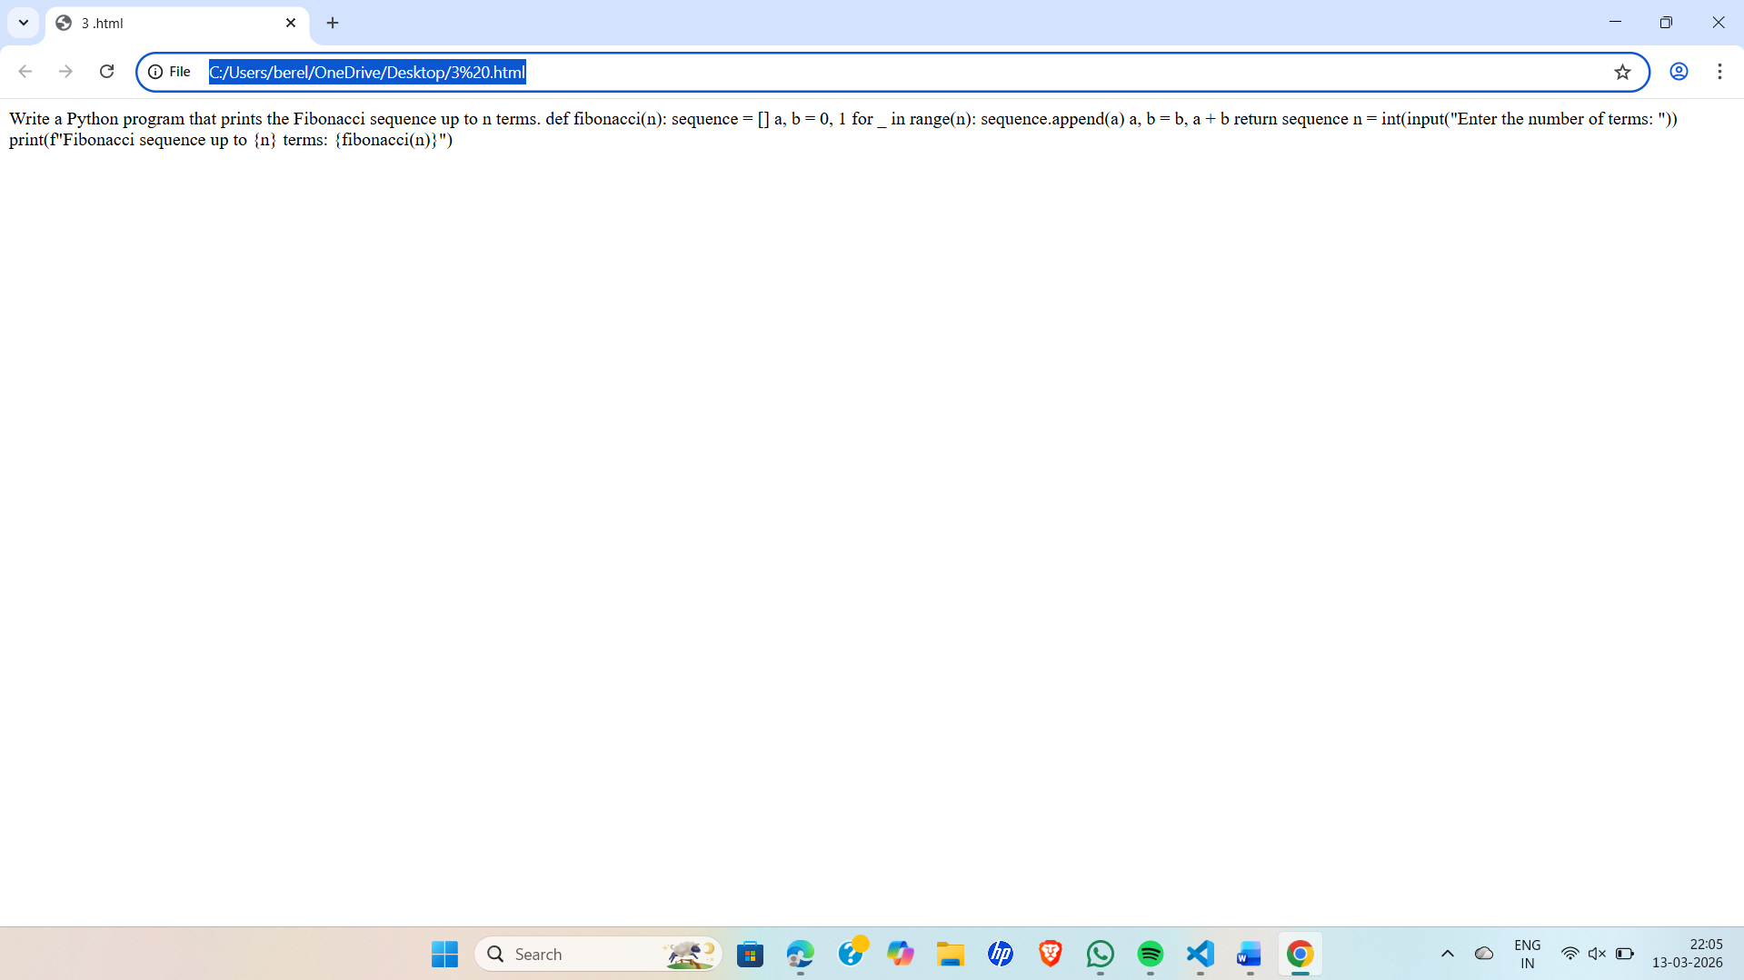
LINK : file:///C:/Users/berel/OneDrive/Desktop/3%20.html
EXPLAINATION : This task requires creating a Python program to print the Fibonacci sequence up to n terms using GitHub Copilot. The program should take n as user input and generate the sequence using loops and variables directly in the main code. No user-defined functions should be used. The aim is to understand basic Fibonacci logic and AI-generated code without modularization.

Task 2: AI Code Optimization & Cleanup (Improving Efficiency)
Prompt : Optimize the following Python code that generates the Fibonacci sequence.
def fibonacci(n):
if n <= 0:
return []
elif n == 1:
return [0]
elif n == 2:
return [0, 1]

sequence = [0, 1]
for i in range(2, n):
sequence.append(sequence[i-1] + sequence[i-2])
return sequence
n = int(input("Enter the number of terms: "))
print(f"Fibonacci sequence up to {n} terms: {fibonacci(n)}")
def fibonacci(n):
if n <= 0:
return []
elif n == 1:
return [0]

sequence = [0, 1]
for i in range(2, n):
sequence. Write a Python program that generates the Fibonacci sequence using a user-defined function.
append(sequence[-1] + sequence[-2])
return sequence

OUTPUT :
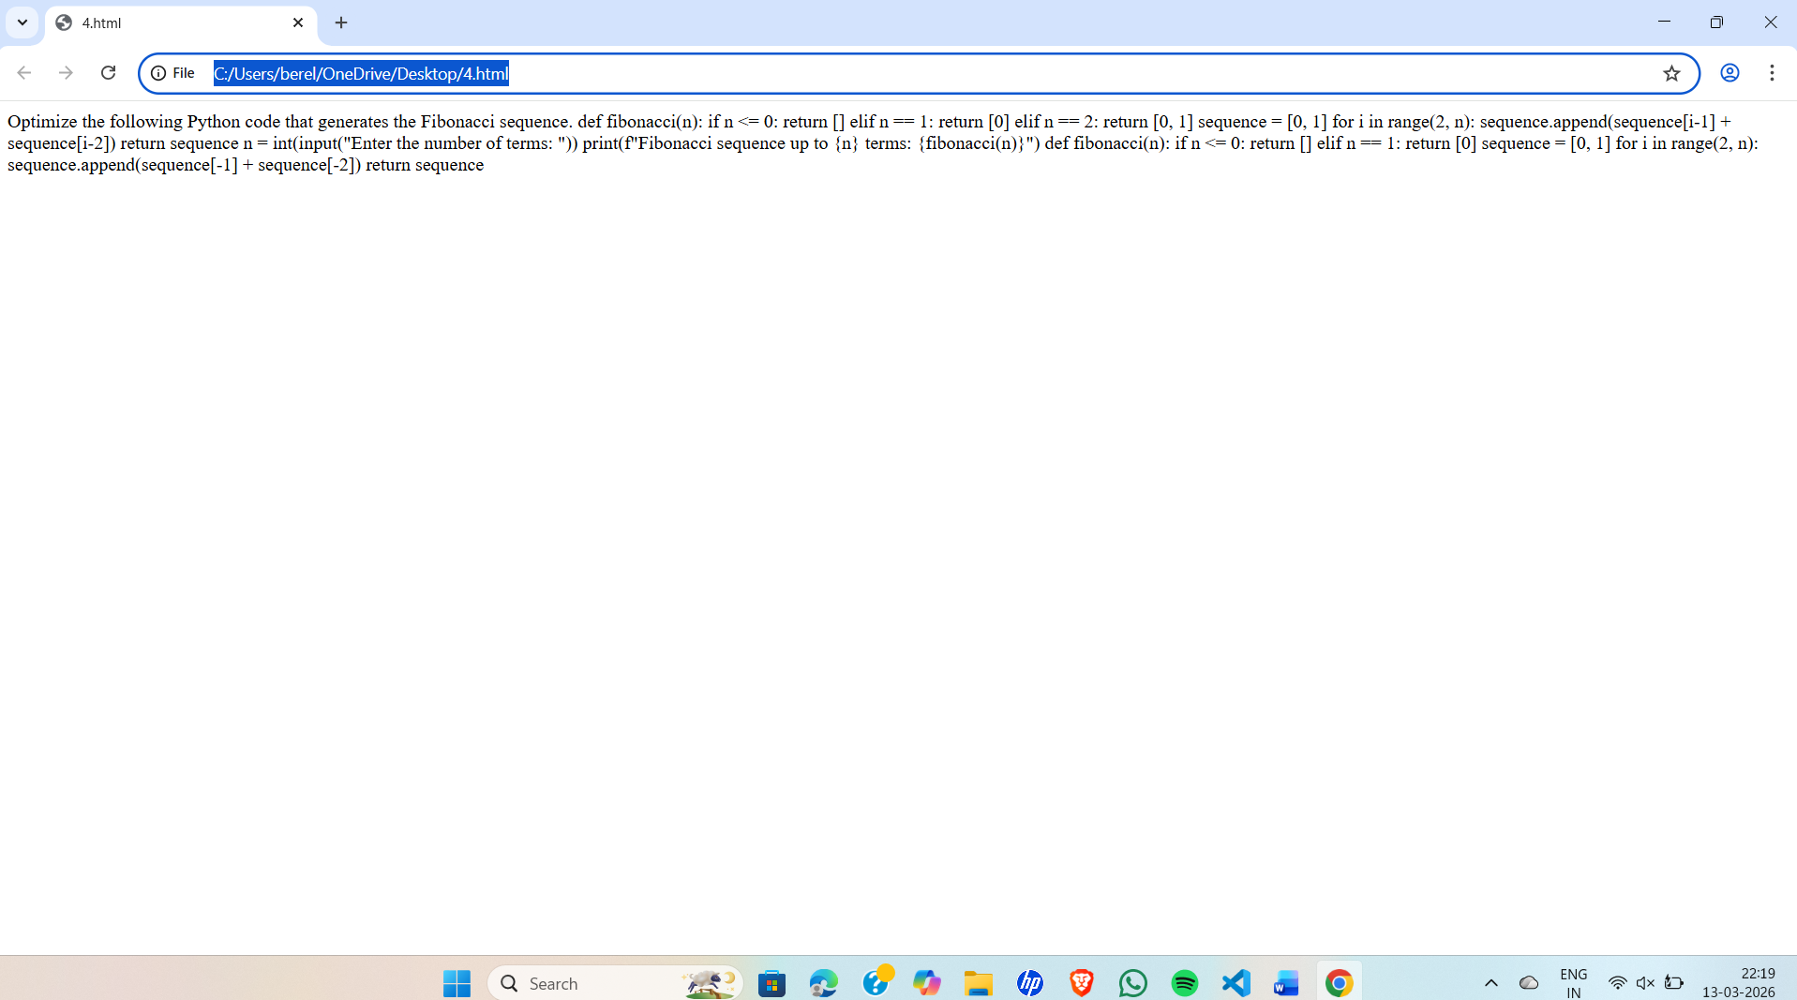
LINK : file:///C:/Users/berel/OneDrive/Desktop/4.html
EXPLAINATION : This task focuses on improving the Fibonacci code from Task 1. You need to optimize the program by removing unnecessary variables, simplifying the loop, and making the code more readable and efficient using GitHub Copilot suggestions. Then compare the original code with the optimized version and explain the improvements.

Task 3: Modular Design Using AI Assistance (Fibonacci Using Functions)
Prompt : Write a Python program that generates the Fibonacci sequence using a user-defined function.
CODE :
Write a Python program that generates the Fibonacci sequence using a user-defined function.
def fibonacci(n):
if n <= 0:
return []
elif n == 1:
return [0]

sequence = [0, 1]
for i in range(2, n):
sequence.append(sequence[-1] + sequence[-2])
return sequence
n = int(input("Enter the number of terms: "))
print(f"Fibonacci sequence up to {n} terms: {fibonacci(n)}")

OUTPUT :
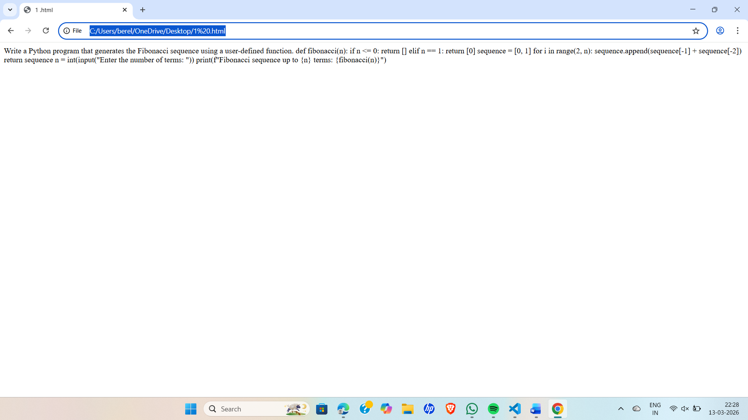
LINK : file:///C:/Users/berel/OneDrive/Desktop/1%20.html
EXPLAINATION : This task requires creating a Python program that generates the Fibonacci sequence using a user-defined function with the help of GitHub Copilot. The program takes n as input, calls the function to generate the sequence, and prints the result. This approach makes the code modular and reusable.
Task 4: Comparative Analysis – Procedural vs Modular Fibonacci Code
Prompt : Compare two Python programs that generate the Fibonacci sequence:
CODE :
Compare two Python programs that generate the Fibonacci sequence:
Program 1:
```python
def fibonacci(n):
sequence = []
a, b = 0, 1
for _ in range(n):
sequence.append(a)
a, b = b, a + b
return sequence
n = 10
print(fibonacci(n))
```Program 2:
```python
def fibonacci(n):
if n <= 0:
return []
elif n == 1:
return [0]
elif n == 2:
return [0, 1]

sequence = [0, 1]
for i in range(2, n):
next_value = sequence[i-1] + sequence[i-2]
sequence.append(next_value)
return sequence
n = 10
print(fibonacci(n))
```Both programs generate the Fibonacci sequence up to the nth term, but they do so using different approaches.
Program 1 uses a simple iterative approach with two variables to keep track of the last two numbers in the sequence. It appends the current number to the sequence list and updates the variables in each iteration.
Program 2, on the other hand, uses a more structured approach with conditional statements to handle edge cases for n = 0, 1, and 2. It initializes the sequence list with the first two Fibonacci numbers and then uses a loop to calculate subsequent numbers based on the last two values in the sequence list.
Both programs will produce the same output for n = 10, which is:
```
[0, 1, 1, 2, 3, 5, 8, 13, 21, 34]
```However, Program 1 is more concise and efficient for generating the Fibonacci sequence, while Program 2
provides more clarity and handles edge cases explicitly, making it easier to understand for beginners.
In terms of performance, both programs have a time complexity of O(n) since they both generate the Fibonacci sequence up to the nth term. However, Program 1 may be slightly faster due to its simpler structure and fewer conditional checks compared to Program 2.
In conclusion, both programs effectively generate the Fibonacci sequence, but they differ in their approach and readability. Program 1 is more concise and efficient, while Program 2 offers better clarity and handles edge cases explicitly. The choice between the two may depend on the specific requirements of the task and the preference of the programmer.
OUTPUT :
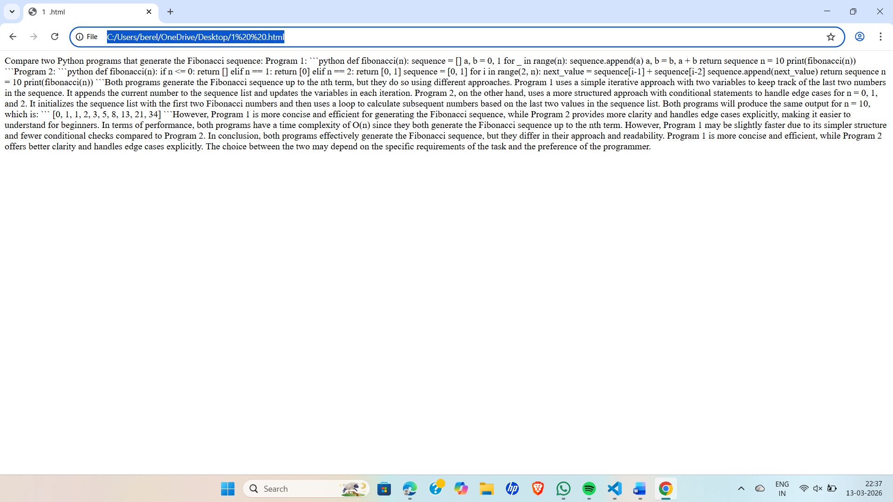

LINK : file:///C:/Users/berel/OneDrive/Desktop/1%20%20.html
EXPLAINATION : This task asks you to compare two Fibonacci programs: one without functions and one with functions. You need to analyze them based on code clarity, reusability, debugging ease, and suitability for larger systems, and present the comparison in a table or short report.

Task 5: AI-Generated Iterative vs Recursive Fibonacci Approaches (Different Algorithmic Approaches for Fibonacci Series)
Prompt : Generate two Python programs to calculate the Fibonacci sequence using different approaches.
CODE :
Generate two Python programs to calculate the Fibonacci sequence using different approaches.
Program 1:
```python
def fibonacci(n):
sequence = []
a, b = 0, 1
for _ in range(n):
sequence.append(a)
a, b = b, a + b
return sequence
n = 10
print(fibonacci(n))
```Program 2:
```python
def fibonacci(n):
if n <= 0:
return []
elif n == 1:
return [0]
elif n == 2:
return [0, 1]

sequence = [0, 1]
for i in range(2, n):
next_value = sequence[i-1] + sequence[i-2]
sequence.append(next_value)
return sequence
n = 10
print(fibonacci(n))
``` Both programs generate the Fibonacci sequence up to the nth term, but they do so using different approaches.
Program 1 uses a simple iterative approach with two variables to keep track of the last two numbers
in the sequence. It appends the current number to the sequence list and updates the variables in each iteration.
Program 2, on the other hand, uses a more structured approach with conditional statements to handle edge cases for n = 0, 1, and 2. It initializes the sequence list with the first two Fibonacci numbers and then uses a loop to calculate subsequent numbers based on the last two values in the sequence list.
Both programs will produce the same output for n = 10, which is:
```
[0, 1, 1, 2, 3, 5, 8, 13, 21, 34]
``` However, Program 1 is more concise and efficient for generating the Fibonacci sequence, while Program 2 provides more clarity and handles edge cases explicitly, making it easier to understand for beginners.
In terms of performance, both programs have a time complexity of O(n) since they both generate
the Fibonacci sequence up to the nth term. However, Program 1 may be slightly faster due to its simpler structure and fewer conditional checks compared to Program 2.
In conclusion, both programs effectively generate the Fibonacci sequence, but they differ in their approach and readability
. Program 1 is more concise and efficient, while Program 2 offers better clarity and handles edge cases explicitly. The choice between the two may depend on the specific requirements of the task and the preference of the programmer.

OUTPUT :
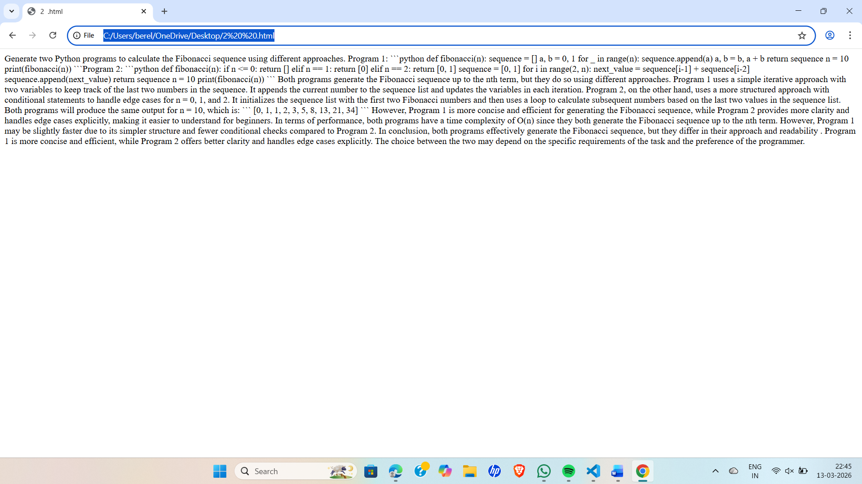
LINK : file:///C:/Users/berel/OneDrive/Desktop/2%20%20.html
EXPLAINATION : This task requires generating two Fibonacci programs using AI: one iterative (using loops) and one recursive (using a function calling itself). Then explain how both methods work and compare them based on time complexity, space complexity, performance for large n, and when recursion should be avoided.

